using System;

namespace CP_Lab_07

{

class Program

{

static void Main(string[] args)

{

// for (int i = 4; i > 0; i--)

// {

// for (int j = 0; j < i; j++)

// {

// Console.Write("{0} ", i + j);

// }

// Console.WriteLine("");

// }

// Console.Write("n = ");

// int n = int.Parse(Console.ReadLine());

// int num = 1;

// int sum = 1;

// Console.Write("The sum 1");

// while (num < n)

// {

// num++;

// sum += num;

// Console.Write("+" + num);

// }

// Console.WriteLine("=" + sum);

// Console.Write("n = ");

// int n = int.Parse(Console.ReadLine());

// int num = 1;

// int sum = 1;

// Console.Write("{0}! is", n);

// while (num < n)

// {

// num++;

// sum *= num;

// Console.Write("*" + num);

// }

// Console.WriteLine("=" + sum);

//Console.Write("n = ");

//int n = int.Parse(Console.ReadLine());

//decimal factorial = 1;

//do

//{

// factorial *= n;

// n--;

//} while (n > 0);

//Console.WriteLine("n! =" + factorial);

//Console.Write("n = ");

//int n = int.Parse(Console.ReadLine());

//int a = 0;

//int b = 1;

//int c = 0;

//Console.Write("The Series is 0,1,");

//while (n > 0)

//{

// c = a + b;

// Console.Write(c + ",");

// a = b;

// b = c;

// n--;

//}

//int n = 1;

//while (n <51)

//{

// double root = Math.Sqrt(n);

// Console.WriteLine("The Square Root of {0} is {1}", n, root);

// n += 2;

//}

}

}

}

Task No 01:

Input:

Console.Write("n = ");

int n = int.Parse(Console.ReadLine());

int a = 0;

int b = 1;

int c = 0;

Console.Write("The Series is 0,1,");

while (n > 0)

{

c = a + b;

Console.Write(c + ",");

a = b;

b = c;

n--;

}

Output:

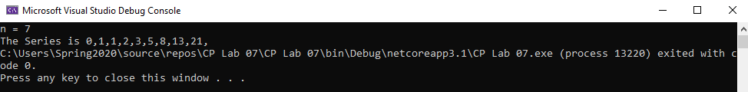

Task No 02:

Input:

Output:

Task No 03:

Input:

int n = 1;

while (n <51)

{

double root = Math.Sqrt(n);

Console.WriteLine("The Square Root of {0} is {1}", n, root);

n += 2;

}

Output:

